Roll No: 2022MC58

Modeling and simulation

TITLE: Model a BLDC

Domain of the problem;

In this 21st century, the electromechanical systems are playing a pivotal role in the multidisciplinary engineering problems. One of the most used system in this century is Motor and while using it we need to first mimic a model to evaluate that how environment conditions will effect on the motor.

So the major problem was that A specific type of motor called brushless Dc motor is now being widely used but we don’t have the equaling model of that motor So that we can see its reactions on different environmental conditions at different parameters.

After designing the system model we will be able to evaluate different responses of a system and get some results that need costly instruments to test and also we will be able to identify the different speed, torque, temperature and other measurable quantities and even without any financial support as we don’t have to buy specific materials to first made the prototype then test the model .For the future enhancements there is space for different things like more then one quantity is variable at a time giving the unexplored behavior.

Graphical Abstract;

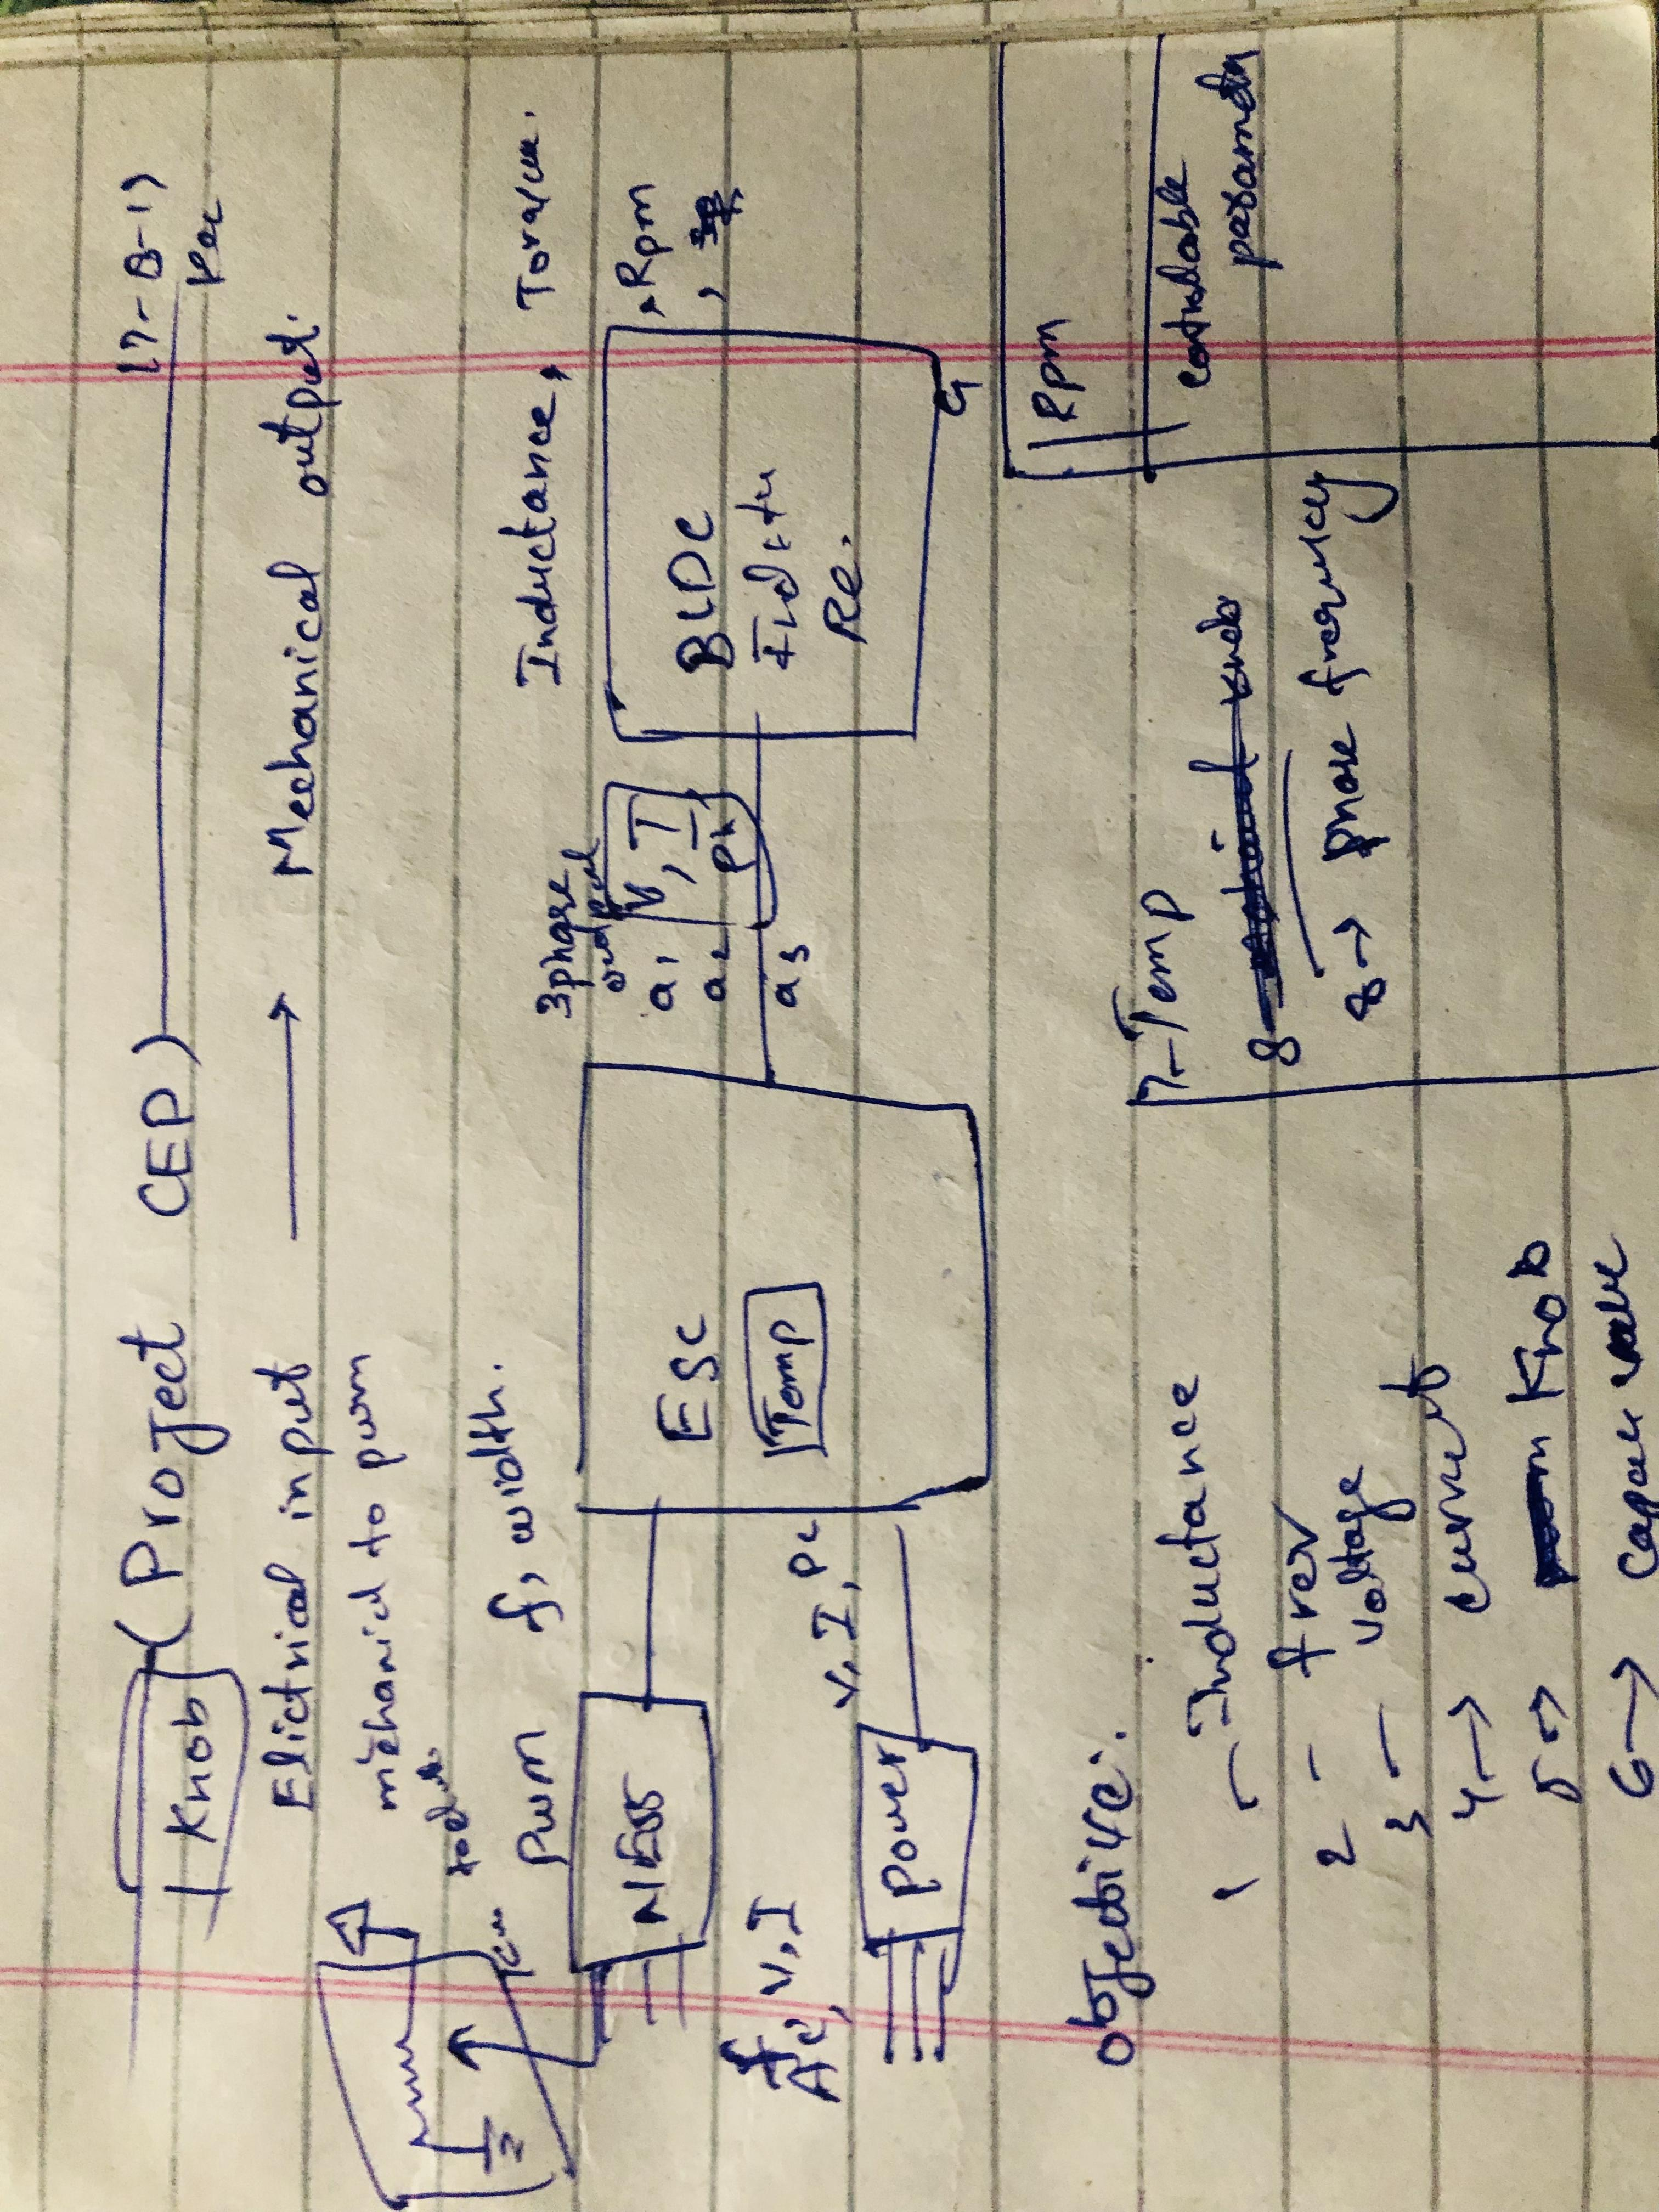

List of Symbols;

|  |  |  |
| --- | --- | --- |
| Sr.No | Symbol | Description |
| 1 | V | Supply voltage |
| 2 | I | Current |
| 3 | Z | Impedance |
| 4 | R | Resistance |
| 5 | $$l$$ | Inductance |
| 6 | $$ω$$ | Angular speed |
| 7 | $$φ$$ | Phase Angle |
| 8 | t | torque |
| 9 | kv | Back e.m.f constant |
| 10 | P | power |

1. Introduction:

BLDC stands for Brushless Direct Current motor used in every mechanical equipment we have is designed to operate on Direct current giving us opportunity to be carried as DC voltage can be obtained from a storage like batteries but major problems may occur if we don’t operate it properly or if we don’t manage the current and other parameter discussed above Optimizely, Hence to Get the optimized and good result from this BLDC motor I would like to design a model that will be able to mimic the system and we will have the will to change its parameters to get an overview that how changing one entity will disturb/Disrupt the system.

Say that you designed a drone comprising this motor and the environment temperature for it was designed was of 30+ but there is temp -4 hence you will again test and make a motor designed to this environment but what if you have a mathematical model of this and you just change the variable value and a graph will show you the behavior.

2. Mathematical Model:

As shown in the image 01 that there are three main subsystems

* Power Source
* ESC (Electronic Speed Controller)
* BLDC(Brushless Direct Current Motor)

Power Source

Hence the main source of power is power supply that can be a battery or something else.

P = VIcos($φ$)/(3)^1/2-------(Input AC)

P = VI---------------------------(Output DC)

ESC (Electronic Speed Controller)

Esc is a sub circuit that takes a pwm signal and power and makes three signals to out as we increase the pwm signal

P = VI---------------------------(Input DC)

5-10%duty -------------------(Input PWM)

V = (I*Z)+Back emf ---------(Output voltagepwm)

BLDC (Brushless Direct Current Motor)

It’s the main sub system that will convert the electrical power to mechanical power and torque

V = (I*Z) +Back emf ---------(Input voltage pwm)

$ω=\frac{I*V*cosφ}{\sqrt{3}t}$------------------(Output RPM)

2.1. Controllable Parameters

* Impedance of the coil
* Radius of the motor
* Voltage
* Current
* Temperature
* Phase
* Duty cycle
* Frequency
* Motor-Velocity constant(kv)
* Back emf constant(1/kv)
* No of Poles

3. Pseudo Code

1. Get the desired peramters
2. Put in Combined system equation
3. Get output after changing the single entity
4. Plot the result
5. Change entity value
6. Plot
7. Show graph

4. Results and Discussion

In this section, Four controllable factors have been varied to investigate the mechanical output of the motor the factors are as bellows

4.1. Influence of Throttle on the Rpm.

4.2. Influence of the temperature on the rpm.

4.3. Influence of Input on the Rpm.

4.4. Influence of Current on the Efficiency.

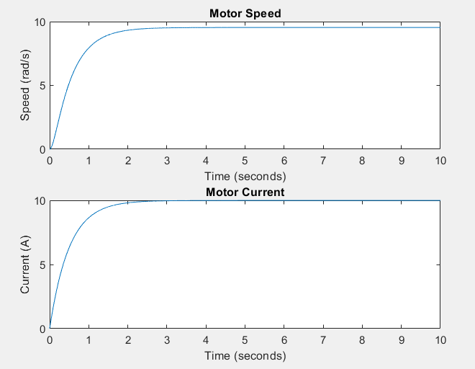 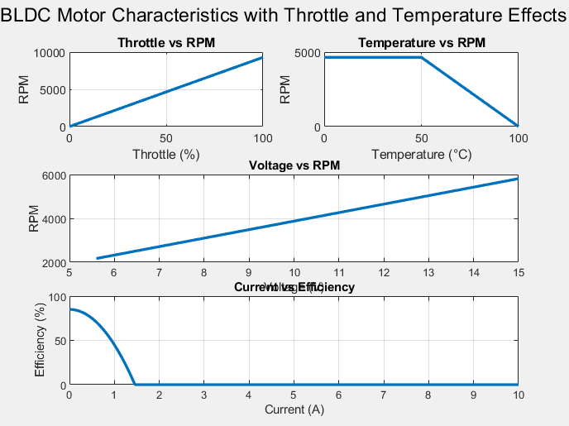 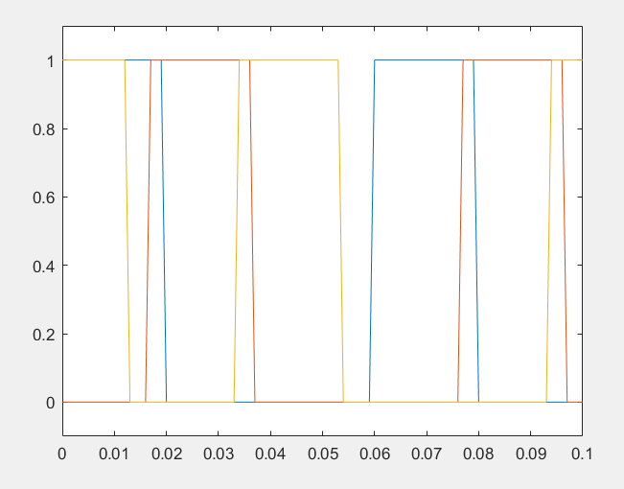(Combined power and pwm signal)

6. Conclusion

One of the noticeable difference is ,that our system is as not perfect as we have the idle system and I used to add temperature parameter tracking the physical properties and also the efficiency of the system

References

[Copilot | Microsoft 365](https://m365.cloud.microsoft/chat?fromcode=bingchat&redirectid=2B537F82DEB1466E8DC476A052EF612A&auth=2&internalredirect=CCM)

Rpm = kv*current

V = (I*Z)+Back emf

$ω=\frac{I*I*\left(r+l\right)cosφ}{\sqrt{3}t}$ (100-t)/100

$$v=rꙍ$$

$$ω=\frac{I*V*cosφ}{\sqrt{3}t}$$

I get these formulas by idealy comparing electrical power with mechanical power and as losses I used temp to match the real world after different rials the original system may not look like aas it is

